**Main title title title title title title title title**

First Author1, Second Author2, Third Author3

1 Baghdad University, College of engineering

Baghdad, Iraq

*author1@email.com*

2 University of Sulaimani, College of Medicine

Sulaymaniyah, Kurdistan Region, Iraq

*author2@email.com*

3 University of Oxford, Department of Engineering Science

 Parks Road, Oxford OX1 3PJ, United Kingdom

*author3@email.com*

**Abstract**: These are the guidelines to assist you in preparing papers for the international journal of Biomodels and Biosimulations (IJBB). To comply with our template, you can transfer the original paper part here in pieces. After completion, you can submit the paper to get in the process.

**Keywords**: keyword1; keyword2; keyword3; keyword4; keyword5; keyword6. (at least 5 key words).

**Introduction**

All texts ‘fonts are Times New Roman. Main title size is 20 and Bold. All other subtitles are 12 in size and bold. All texts and paragraphs are (justify) in regards to the arrangement. References style is ISO 690. Citation should be arranged and entered through Microsoft word.

**Page Size and Layout**

The size of the paper are A4 and the borders are normal. Page border is only on the left and right.

**Figures and Tables**

You should provide good high-quality figures. Ony figures and tables are allowed to be central.



*Figure 1 the text related to the figures should be placed in this format. Times new roman, 10 in size. italic and bold*

Tables

Place table titles above the tables.

|  |  |  |
| --- | --- | --- |
| Margin | A4 Paper | US Letter Paper |
| Left | 18.5 mm | 14.5 mm (0.58 in) |
| Right | 18mm | 13 mm (0.51 in) |

*Figure 2 table will be regarded as figures*

**References**

Number citations consecutively in the style ISO 690. The author should provide the original text in parentheses with red color as in the next example. The pollution is highly dependent upon the air inlet and outlet. (1)

(The locations of the inlet and exhaust ports affect the concentration of indoor air pollutants, including in general work rooms and operating rooms.)

The sentence punctuation follows the brackets. Multiple references are each numbered with separate brackets (1) (2). Please note that the references at the end of this document are in the ISO 690 referencing style. Please ensure that the provided references are complete with all the details and also cited inside the manuscript (example: page numbers, year of publication, publisher’s name etc.).

The references should be uploaded with the initial submitted document.

**Equations**

If you are using Word, use either the Microsoft Equation Editor or the MathType add-on (http://www.mathtype.com) for equations in your paper (Insert | Object | Create New | Microsoft Equation or MathType Equation). “Float over text” should not be selected.

Number equations consecutively with equation numbers in parentheses flush with the right margin, as in. First use the equation editor to create the equation. Then select the “Equation” markup style. Press the tab key and write the equation number in parentheses.



Other recommendations

Equalize the length of your columns on the last page. If you are using Word, proceed as follows: Insert/Break/Continuous.

**References**

1. *Optimization of a hospital room by means of CFD for more efficient ventilation.* **Méndez, C.** Issue 5, 2008, C. Méndez, J.F. San José, J.M. Villafruela, F. Castro, Vol. Volume 40, pp. 849-854.

2. *Numerical simulation of air age in dental offices.* **Nambu, E., Nozaki, K., Tsubokura, M. et al.** 2022, Scientific Reports.

**Author Profile**

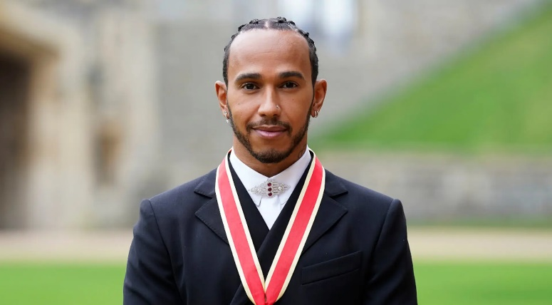

Taro Denshi received the B.S. and M.S. degrees in Electrical Engineering from Shibaura Institute of Technology in 1997 and 1999, respectively. During 1997-1999, he stayed in Communications Research Laboratory (CRL), Ministry of Posts and Telecommunications of Japan to study digital beam forming antennas, mobile satellite communication systems, and wireless access network using stratospheric platforms. He now with DDI Tokyo Pocket Telephone, Inc.



Figure 4 Figure 1 This figure had dimensions of 875pixles *748pixles. Its size is 6.66KB and the print resolution is 300pixle/inch. This text should be italic.